**La-Z-Boy Product Descriptions (250 character limit)**

**The Roscoe Power Reclining Sofa**

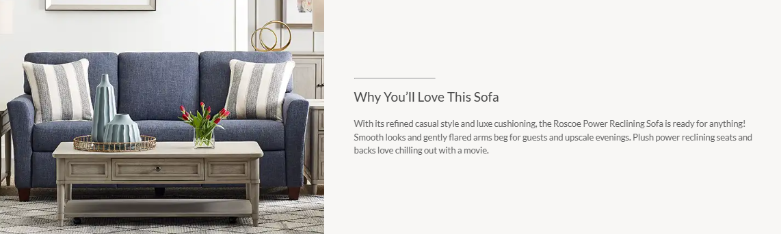

**The Cleo Swivel Chair**

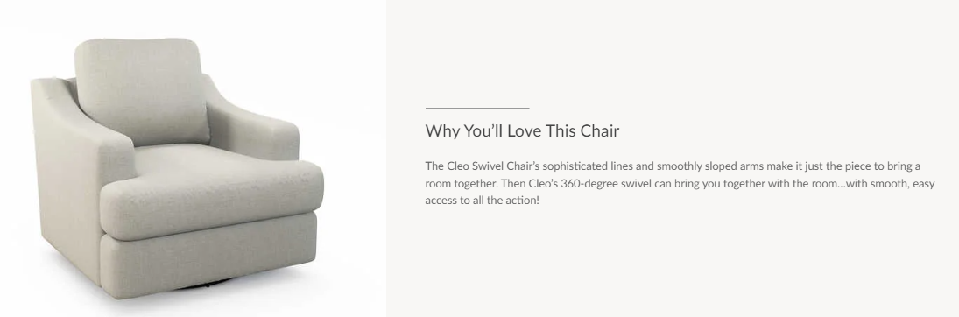

**The Talladega Power Wall Recliner with Headrest & Lumbar**

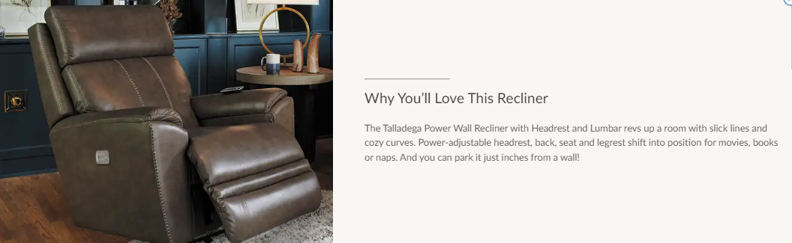

**The Kirby Chair and a Half**

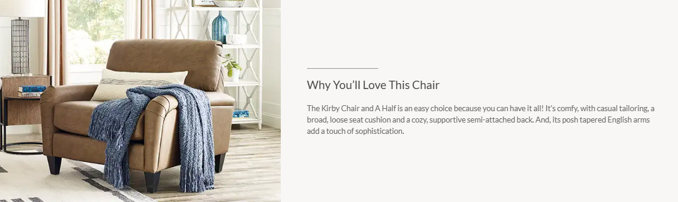

**The James Power Reclining Loveseat with Headrest**

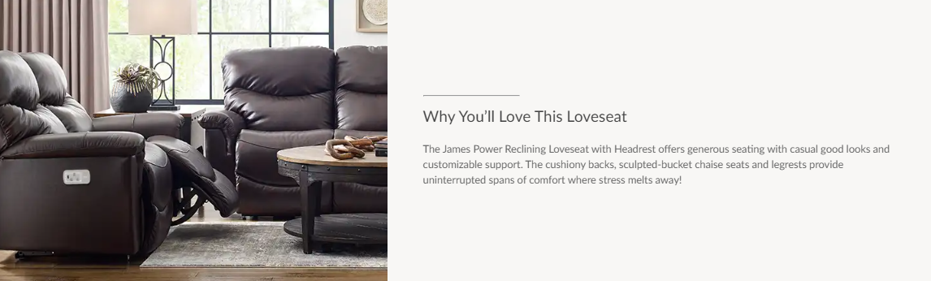

**The Petra Deep Long Sofa**

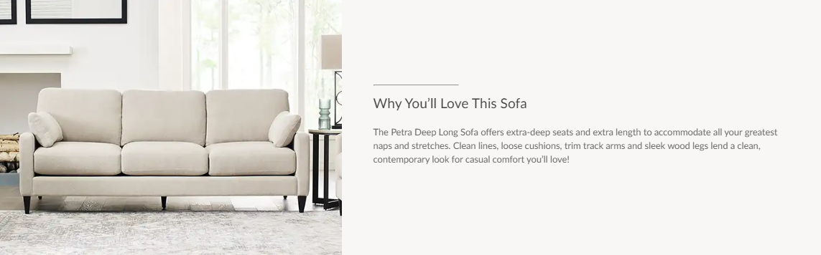

**The Ava Reclining Sofa**

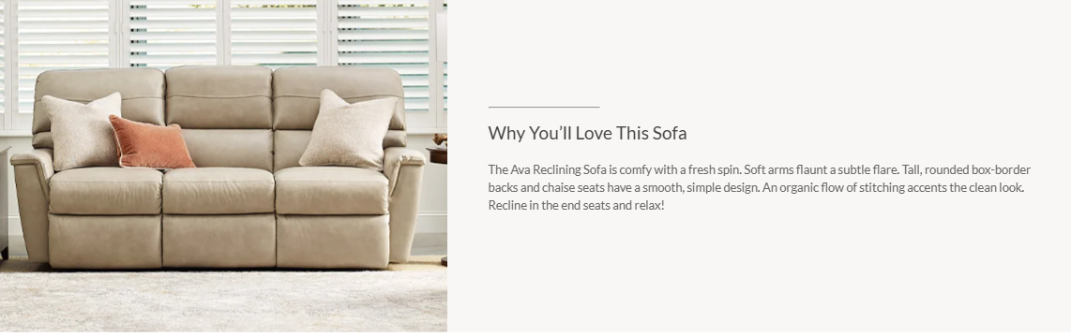

**The Olson Twin Sleep Chair**

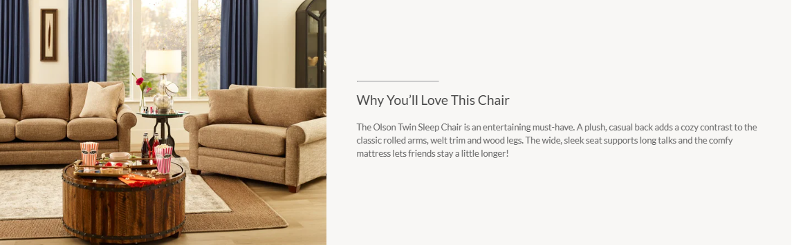

The Apollo Reclining Sofa

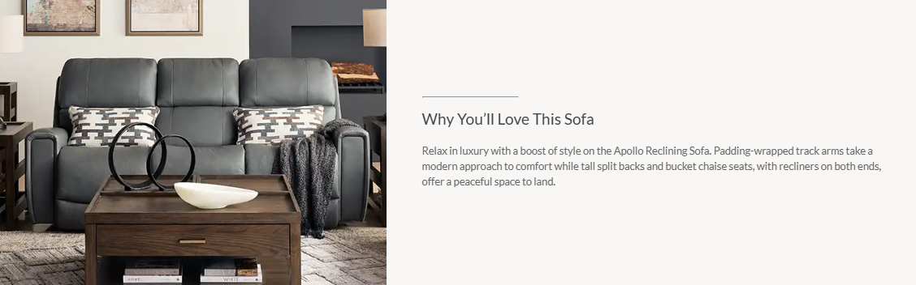

**The Hawthorn Reclining Loveseat with Console**

